Fission means ‘splitting’ and fusion means ‘joining’.
A rock may have a fissure in it – a split. We can fuse or join things together.

So one splits and one joins!

Task 1 – Nuclear fission

Use the words in the box to fill in the gaps. Some may be used more than once and others not at all.

krypton-90 | gamma | energy | atom | steam | chain
turbine | -235 | uranium-236 | isotope | proton | minimum
absorbed | power | two or three | barium-143 | critical | radioactive
electricity | neutrons | water | radiation | neutron | nuclei
maximum | reactor

A slow moving …………………. strikes a uranium ……………. nucleus and is ……………………………, forming
another isotope, uranium – ……..…… . This is very unstable and it splits into two smaller
………… .

As part of the process, ………………..….. neutrons are released, as well as a large amount of
……………………… and …………………….. radiation. The new nuclei formed are new substances. They are ….……………………… and ………………………… .

So what happens to the energy released? The reaction is a controlled reaction and it happens
within a nuclear ……………………, in a nuclear …………………… station. The energy released is used to heat ……………………, and the ……………………. from this turns a ……………………….. to produce ………………………………. .

The neutrons produced can then go on to split further uranium nuclei. This is known as a
……………………. reaction.
The amount of uranium used is important. It has to be large enough to contain …………...……… but not too large. The ………………………. amount needed to sustain the nuclear reaction is known as the ………………………. mass.

Disposing of the waste ………………………… material created during nuclear fission remains a problem.

Task 2 – Nuclear fission

Complete the equations below, showing the reaction when uranium-235 absorbs a neutron.

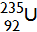

______+______+______+______+______+______+______

Task 3

Below is a diagram to represent what happens when a neutron is absorbed by a Uranium 235 nucleus. To help you understand what is happening, add some notes in your own words (‘annotate’ it).

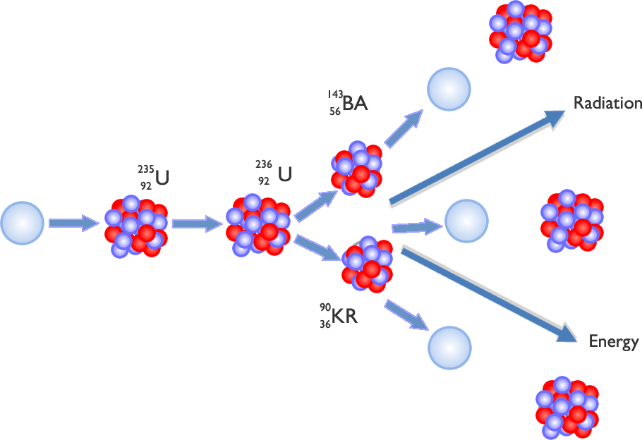

Task 4 – Nuclear fusion

Use the words in the box to fill in the gaps. Some may be used more than once and others not at all.

technology | neutrons | energy | 100 | nuclei
Sun | greater | repelling | fission | attraction
mass | temperatures | fusion | weight | electrons
hydrogen | reactor | protons | radioactive | scientists
stars | electromagnets | positively | atoms | cleaner
1 000 | balloons | negatively | 10 000 000 | Earth
less | hydrogen | helium | more

In nuclear ……….………….…, two light ……………..……. are joined or ‘fused’ together. It is the same type of reaction that powers ……………..………. bombs and the …………………. . In nuclear fusion, large amounts of …………………. are produced when two atoms join together to form one.

In a fusion …………….………, at very high …….…………………………………. and pressure, hydrogen nuclei come together to form …………………….. atoms, …………….…….… and vast amounts of energy. The hydrogen nuclei are ………..…………. charged ……………..……, and large amounts of energy are needed to overcome the ………………..…. forces of these charges.

Weight for ……..………………, the amount of energy released is ……………………. than in nuclear fission, but there are problems controlling the energy produced and therefore the reaction as a whole.

All the energy released by ………………… comes from fusion. However, on ………………………, the very high temperature needed (about ………………………… ºC) is difficult to create. The hydrogen nuclei, once under high temperature and pressure, are difficult to contain and giant …………….………………………… are needed.

It is believed that this would be a …………………, safer and …………………… efficient source of power than nuclear fission. It does not leave behind waste …………………………… material. ………………………… continue to develop the …………………………… to make it possible.

Task 5

Complete the equations below, showing the reaction when two hydrogen nuclei fuse to create a helium nucleus.

______________ + ______________

