- Atoms are made up of three principal particles - protons, neutrons and electrons. Complete the table below which compares their properties.

Particle | Relative mass | Charge
protons
neutrons
electrons

- This is a representation of an atom. Label A, B, and C.

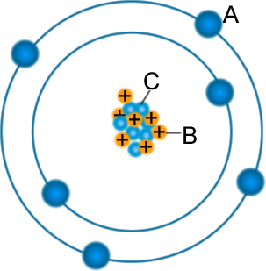 | A  B  C

- Why do atoms have no net charge?

- If an atom loses or gains an electron, it becomes a charged particle or

- What does the top number represent, atomic mass or atomic number?

What does the lower number represent, atomic mass or atomic number?

 | 12 | C
 | 6

- In any atom, the atomic number is

- In any atom, the atomic mass is

- Here is a mystery element. What can you say about it?

148 | A
74

- Using the same method as in Q8 for showing the information, how would a helium atom be represented?

- Which sort of radioactive particle is a charged helium nucleus?

- Do all atoms of the same element have the same number of protons?

- Some atoms of the same elements have a different number of

- These atoms are called

- The nuclei of six unidentified elements are shown below. Circle the ones which are
isotopes of each other.

92 | 125 | 92 | 92 | 121 | 132
48 | 47 | 38 | 39 | 45 | 47

- What helped you decide your answer to question 14?

- What is a radioactive isotope?

- What happens when a radioactive isotope breaks down and what do we call this ‘breakdown’?

- Following radioactive decay, what three types of radiation could be emitted?

1. 2. 3.

- Which one has a negative charge?

- Describe where and how this type of particle is formed.

- Fill in the empty boxes.

Alpha particle = |  | α | Beta particle = |  | β

- Look at the isotopes below. Choose one to complete the equations.

a) V → + α | b) W → + β

92 | 125 | 92 | 92 | 121 | 132
48 | 47 | 38 | 39 | 45 | 47

Neutrons are used in nuclear fission (fission means splitting) to split some very large unstable nuclei. What is released when this happens and what is formed?

If the conditions are correct, the neutrons can then continue the process. What name do we give to this type of reaction?

