Multiple choice
- Which of these shows the correct units for both energy and power?
 | Energy | Power
A | kilowatt | joule
B | joule | kilojoule
C | kilojoule | watt
D | watt | kilowatt
- Which of these could cause an electrical fire in the home?
1. | Old, frayed wiring |  | 2. | Over-loaded sockets
3. | Miniature circuit breakers |  | 4. | Damaged plugs
- 1, 2 and 3
- 1, 2 and 4
- 2, 3 and 4
- All of these
- A residual current circuit breaker (RCCB) works because it
- detects any difference in current between the live and neutral wires.
- stores any additional current that is passing through the circuit.
- detects any difference in current between live and earth wires.
- detects any current passing though the earth wire.
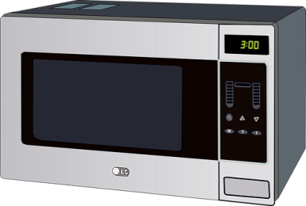
- Which of the following electrical appliances would use the most electricity (electrical energy in kilowatt-hours)?
- 60 W light bulb used for 1 hour
- 1 kW hairdryer used for 5 minutes
- 40 W tablet computer used for 2 hours
- 600 W microwave used for 10 minutes

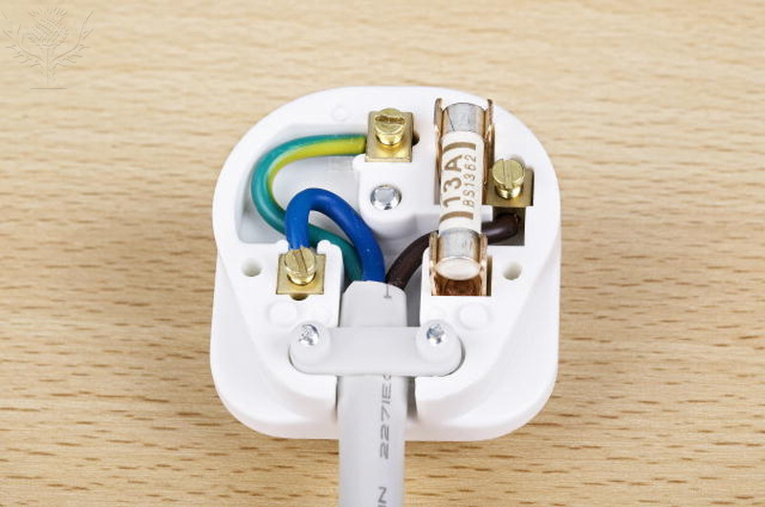
Inside of a three-pin plug and three fuses./ Credit: SHEILA TERRY/SCIENCE PHOTO LIBRARY / Universal Images Group / Copyright © Science Photo Library / For Education Use Only. This and millions of other educational images are available through Britannica Image Quest. For a free trial, please visit www.britannica.co.uk/trial
- Which of these statements about a household plug is not correct?
- The fuse should always be a 13 A fuse.
- The live wire is connected closest to the fuse.
- The blue wire is the neutral wire.
- The earth wire is at zero voltage.
- An electrician rewired a room to include two new ceiling lights. These he connected in parallel so that if one blew the other would still work. Both lights could be switched on from one switch. The electrician then wanted to include a protective fuse for these lights.
A
C
D
B
Neutral wire
Mains
Live wire
In which position A, B, C, or D in the above circuit diagram should the protective fuse be placed?

Question 7 and Question 8
These two questions refer to identical heating elements in an electric oven. They are represented by R and S in the diagrams. By using a suitable switch they can be connected in various ways so that they can produce the ‘low’, ‘medium’ and ‘high’ for the oven.
R  S  240 V  Low | S  240 V  Medium | R  S  240 V  High
The oven operates at 240 V and each heating element has an electrical resistance of 30 Ὠ when cold but this rises to 40 Ὠ under normal operating conditions.
- If the wire to the heating element R is broken, the oven could still be heated with the switch set to .
- ‘medium’ only
- ‘medium’ or ‘high’
- ‘low’, ‘medium’ or ‘high’
- ‘high’ only
- What is the current used by the oven when it is set on low setting?
- 3 A
- 6 A
- 8 A
- 12 A

Structured Questions
- The diagram shows a 240 V electric hair dryer. Switch S₁ is the mains switch and switches S₂ and S₃ are the switches for the heating coils.
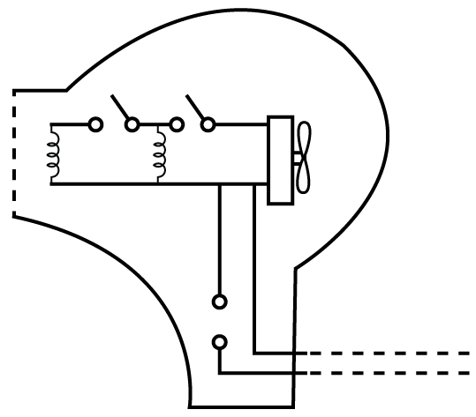
Two heating coils
Plastic case
Electric fan
Mains
plug
S₁
S₃
S₂
- (i) Explain why the heating coils are arranged in parallel? [1 marks]

(ii) Can the heating coils be switched on without the electric fan being on? Explain your answer. [2 marks]

- The electric fan takes a current of 0.5 A, and each heating coil takes a current of 1.5 A.
(i) What is the resistance of each heating coil? [2 marks]

(ii) Which fuse rating (3 A, 5 A or 13 A) should be used in the mains plug? Explain your choice. [2 marks]

- Complete the paragraph about electrical safety in the home by choosing from the following list of words. Each word can only be used once. [5 marks]
electrician |  | energy |  | electrocution |  | circuit breakers |  | overheating
clean | wet |  | socket |  | switch |  | fuses |  | appliances

Electricity in the home is potentially dangerous and of wires
can cause electrical fires. Electric shock or can occur if you touch live wires.
Always play it safe and use suitable in plugs and
in main’s circuits. Never plug in too many into one ...
Always off electric lights, if not in use, to save ,
but never switch off with hands. Never an electrical appliance that is switched on. Finally always get a qualified
to do electrical repairs if a fault is discovered.
[Total = 20 marks]

