Task 1
Complete the sentences using your knowledge and the keywords below.
chromosomes | 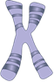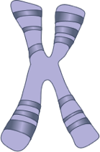 |  |  | Chromosomes are found inside the __________ of a cell.  There are ________ pairs of chromosomes in every human body cell.  One of each pair of chromosomes comes from each__________.  Chromosomes are made up of long lengths of _________.
genes | 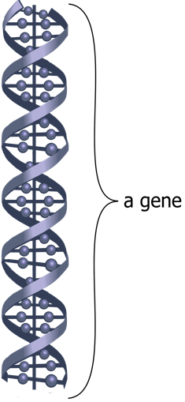 |  |  | A gene is a short section of a ______________________.  Each gene ____________ for a different _________________.  Genes work in ____________. There are different versions of each gene, one is often ________________ over the others.
DNA | 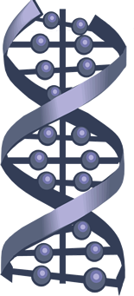 |  |  | DNA is short for ________________________ ___________.  It is a long chain ________________ that is made up of a combination of __________ DNA bases.  DNA has a special structure called a _________ _________.
Keywords
4 | DNA | pairs | double |  | nucleus | characteristic | chromosome
23 | codes | helix | molecule |  | parent | dominant | deoxyribonucleic acid

Task 2
Draw lines to match up the beginning and the end of the sentences
DNA is short for … |  | ... called a double helix.
Chromosomes contain many genes that … |  | … deoxyribonucleic acid.
Genetic material is found… |  | ... 4 DNA bases.
There are 23 pairs ... |  | ... controlled by genes.
DNA is a molecule made up of a combination of ... |  | … of a chromosome.
We inherit our genes ... |  | … code for our characteristics.
Each gene is a short section ... |  | … long coiled chains of DNA.
Chromosomes are made up of … |  | … of chromosomes in the nucleus of a body cell.
DNA has a special structure … |  | ... in the nucleus of each cell.
Our characteristics are ... |  | ... from our parents.

