Task
For each pair of linked keywords, write a sentence including them both.
For example:
1. The kidneys regulate the water content in the body.
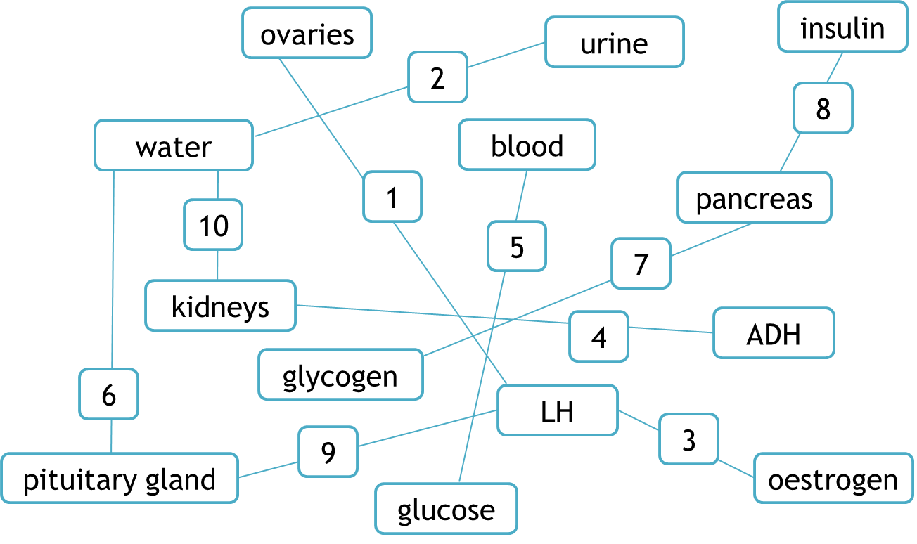

1. | The kidneys regulate the water content in the body.
2.
3.
4.
5.
6.
7.
8.
9.
10.

Teaching notes
This activity is ideal as a quick starter to recap hormonal coordination in humans.
The resource can be adapted to use different keywords for different topics.
Ideas for differentiation:
- allow free choice to pair different keywords together
- ask students to link more than two keywords together
- change the links between keywords to make them more straightforward or more challenging.

