Models of the atom
Figure 9 shows two models of the atom. Figure 9
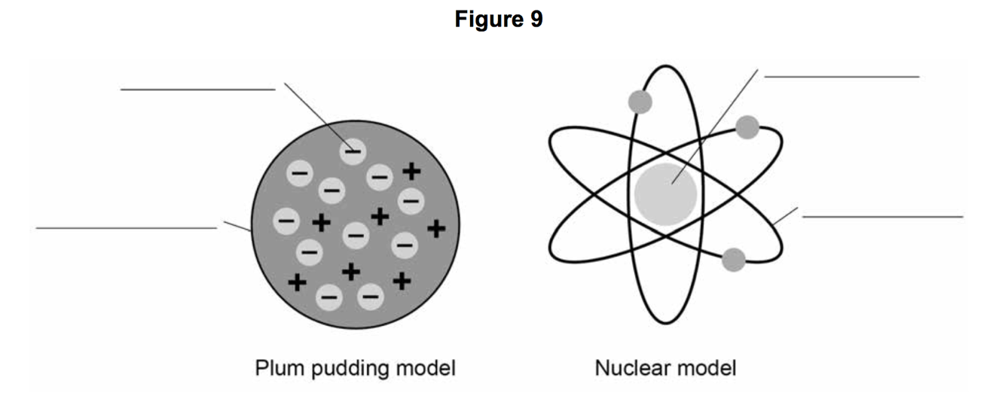
Write the labels on Figure 9. Choose the answers from this list:
atom - electron - nucleus - neutron - orbit - proton
[4 marks]

Explain why the total positive charge in every atom of an element is always the same.
[2 marks]

Which model is the closest to the actual structure of an atom?
[1 mark]

Give an account of Rutherford’s ‘gold foil’ experiment and what conclusions were drawn from it.
[4 marks]

